Home Communication System

Micro:Bit

There are many different commands on the micro: bit home communication system. I chose some commands that I thought would be used quite a bit. These can be easily changed using Make Code; in blocks or using Java Script.

Blocks can be seen on the left and Java Script can be seen on the right. I have made a [GitHub](https://github.com/NathanOC04/Micro-Bit-Home-Comms) repository where you can download the hex file. You then open the hex file on the [MakeCode](https://makecode.microbit.org/) website. For people that don’t know how to use Java Script, they can use the blocks which is a lot easier to use. Once they look at it and try to understand it, it is very easy to customize for your own needs.

# Default Commands:

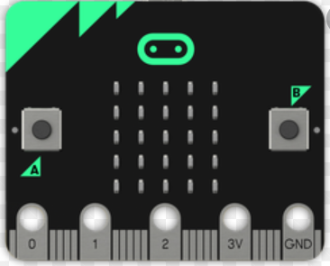There are default commands that are programmed into the hex file. I will list the different commands below. The pin commands below can be a bit awkward to use. On the right you can see the Micro:Bit. There are five pins at the bottom. Three of the five pins can be used; Pin 0, 1 and 2. To use these you have to hold your finger on the GND pin and then put your other finger on the pin you want to use. This can be a bit annoying to do but eventually the message will send. You will get a tick to say it is sent.

1. Button A:
   1. Sends message “Hello”
2. Button B:
   1. Sends message “Come here”
3. Button A+B:
   1. Sends a love heart icon
4. Pulling the Micro:Bit logo towards you:
   1. Sends message “Ok”
5. Pulling the Micro:Bit logo away from you:
   1. Sends message “No”
6. Press Pin 0:
   1. Sends message “Dinner is ready”
7. Press Pin 1:
   1. Sends message “Im going out”
   2. Since you can’t put an apostrophe in a string the message says Im instead of I’m
8. Press Pin 2:
   1. Sends message “Rock Paper Scissors”
   2. This is supposed to be a question but you can’t put question marks in strings.
9. Shaking the Micro:Bit:
   1. This will display a rock, paper or scissors. This will hopefully encourage the people using the Micro:Bit to play a game of rock paper scissors. It is a very simple game, but simple can be fun.

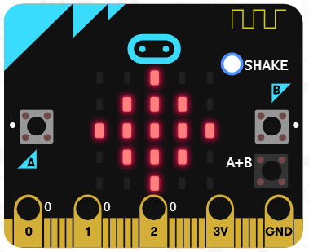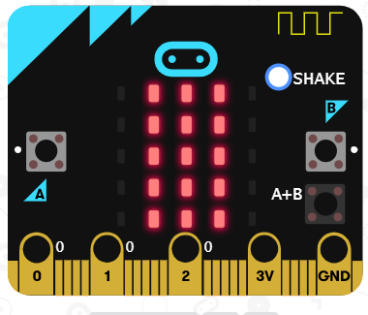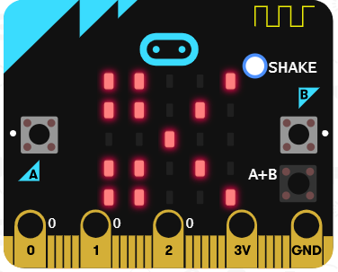

3 Scissors

2 Paper

1 Rock